Assignment 3: Accessing Data Part II

Part I

1. Accountant: “Can you give me all the details for the employees that are either the manager or the assistant manager?"

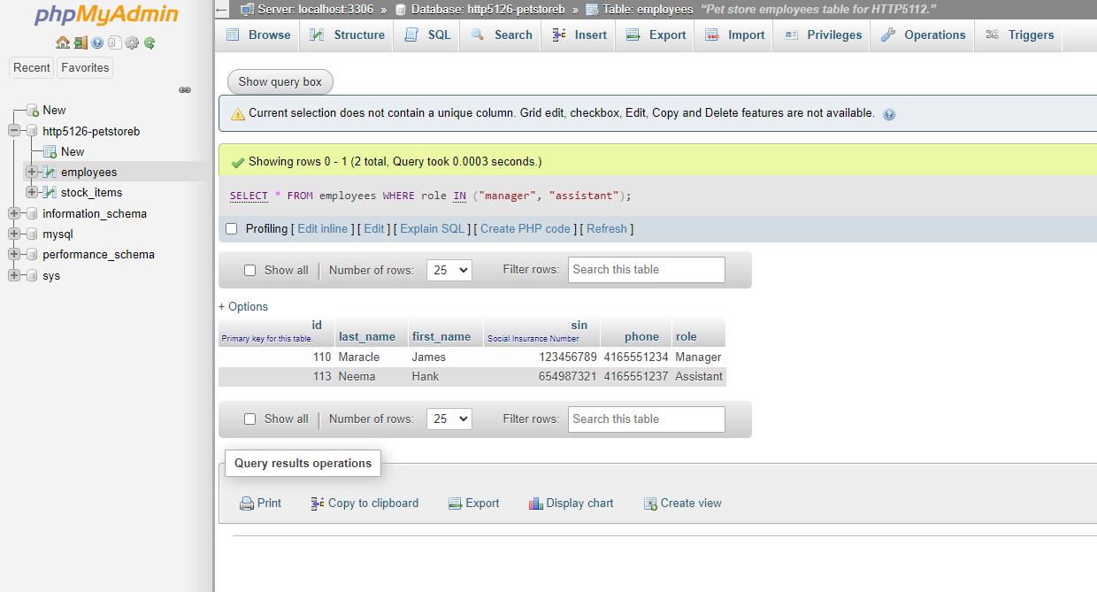

OR method  
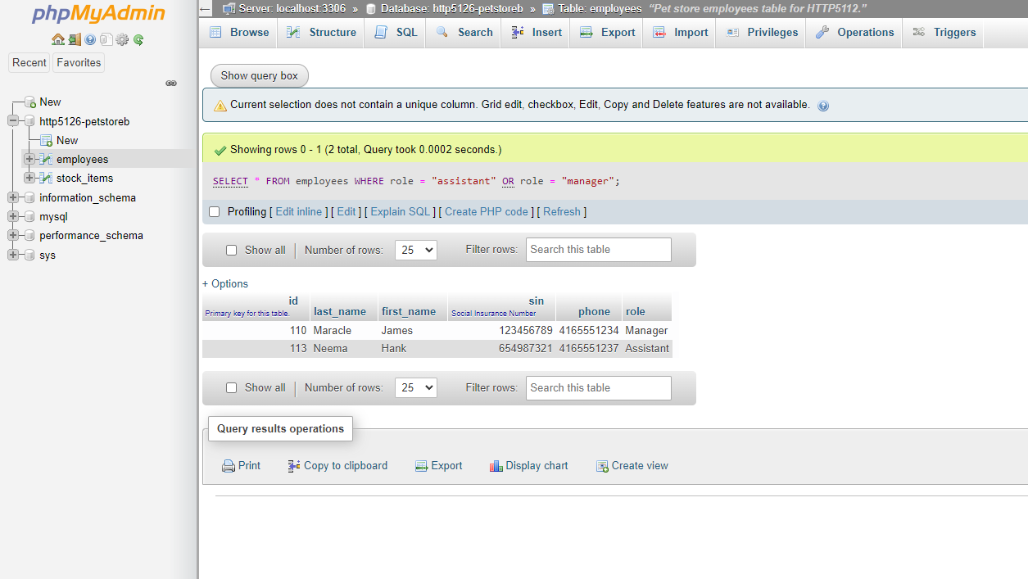

1. Assistant Manager: “Our fish supplier called, can you show me all of the data for our fish (piscine) items that have an inventory count of less than 24?"

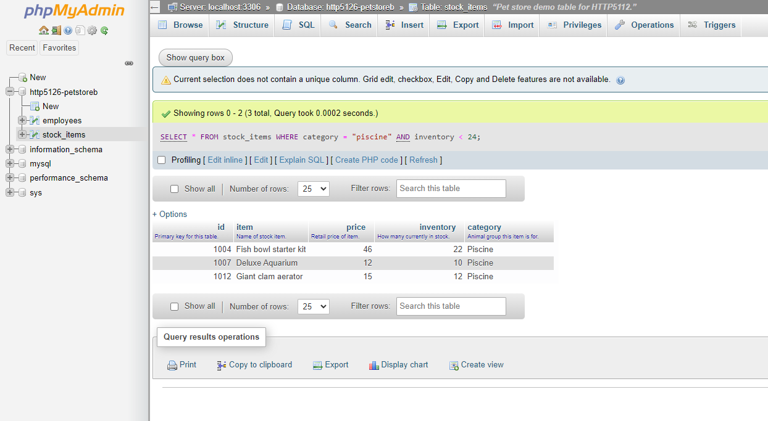

Part II

A. Customer: “What kind of cages do you have, and how much are they?”HINT: What items do you have that end in “cage”?

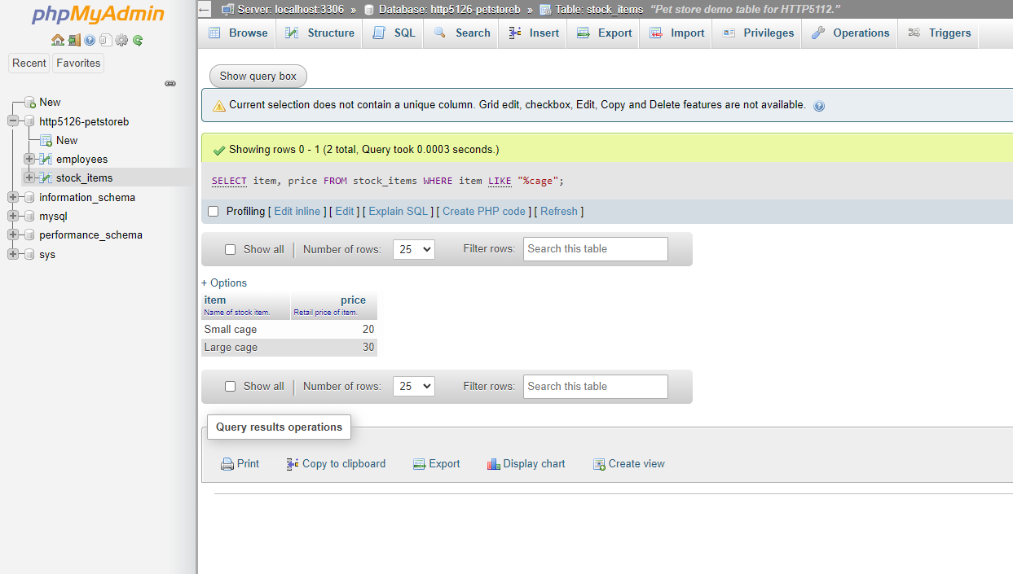

B.Customer: “I was speaking with one of your sales associates, but I can’t remember his name. It starts with F”. HINT: What first name starts with F?"

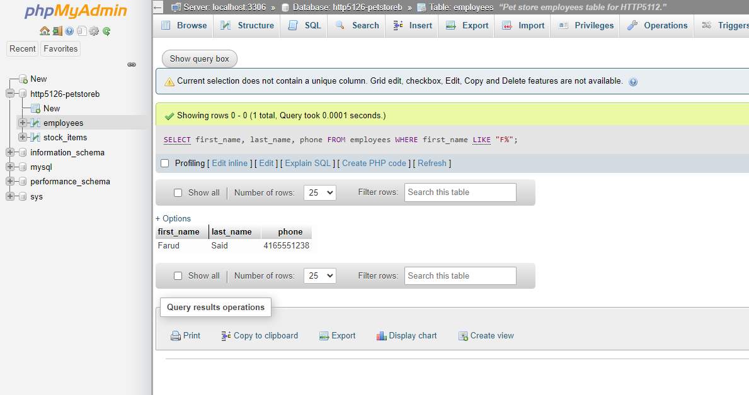

Part III

A.The assistant manager is doing an inventory report and needs full detailsfor all items with an id between 1010 and 1015 (inclusive).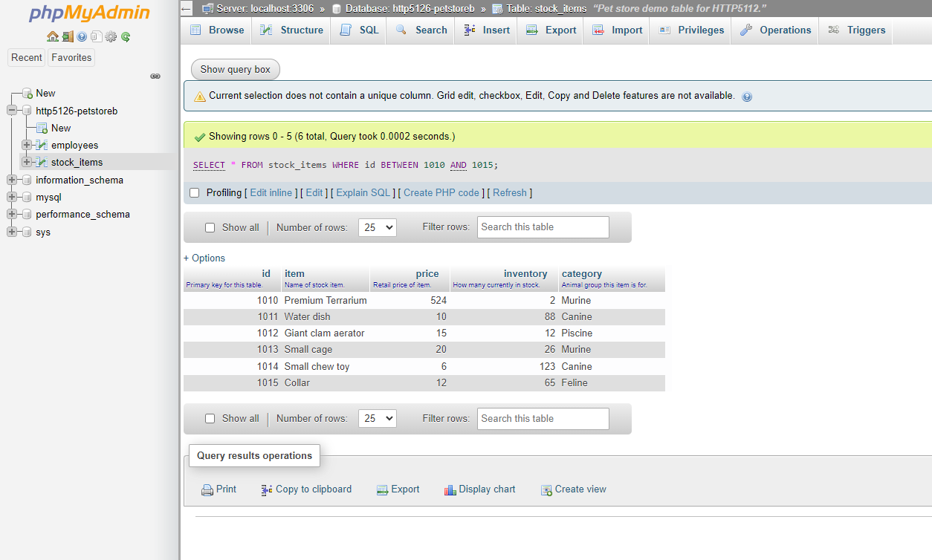

B. Customer: “I’m buying something for my friend’s dog, but my budget is$10-$20. What have you got in that range?”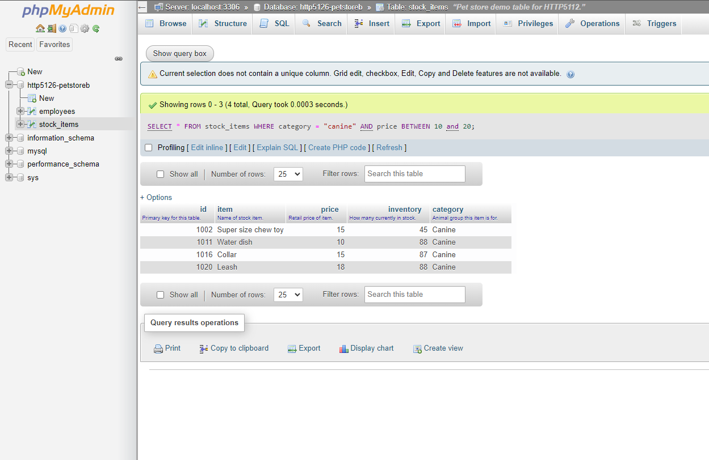

Part IV

A.The manager is creating a contact list. Create a query that provides the firstnames, last names, “Job Title” and phone numbers for all employeesexcept the manager in alphabetical order by last name.

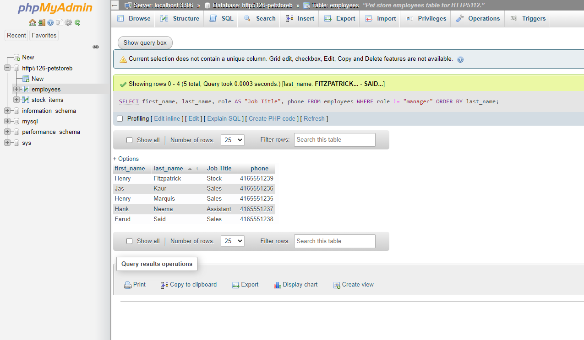

B. Next week is “Murine Monday” and there will be a sale on select items for hamsters and guinea pigs. Provide the manager with a list of items (id, item,price, inventory) from this category that has more than 20 items in stock. It should be listed from the most expensive to the least expensive.

